 | Autumn 1 | Autumn 2 |  | Spring 1 | Spring 2 | Summer 1 | Summer 2
Owlets | Favourite book week.  Spot books  Big Book of Feelings  How do you feel?  Spot loves his Friends  Are you ready?  Bear and the Picnic Lunch.  Good Morning Song  Sleeping Bunnies  If you’re happy and you know it..  Head, shoulders, knees and toes…  How do you feel?  We’re going on a pumpkin hunt. | We’re going on a Pumpkin Hunt  That’s not my Witch  Rosie’s Walk  Autumn Babies  That’s not my Hedgehog  Here comes Spring  Spot goes to the Library  5 little pumpkins  I’m a little hedgehog  All the leaves are falling  Dingle dangle scarecrow |  | Fidgety Fish  Bright Stanley  What lives in the sea?  Splash  5 little speckled frogs  1,2,3,4,5 once I caught a fish alive  Row, row your boat  Jack and Jill  Incy wincy spider  A sailor went to sea  Winter | Spot goes to the farm  Noisy farm  On the Farm  I eat Vegetables  I am a Rabbit  Muddle Farm  Old Macdonald had a farm  Baa, baa black sheet  This little Piggy  Little Bo Peer  5 little ducks  Here we go round the mulberry bush  I’m a tiny seed | Zoom, Rocket, Zoom  Maisy goes on a Plane  Choo, Choo  Tatty Tractor  Dig, dig digging  The wheels on the bus  We’re driving in our car  5 little men in a flying saucer  Sticky ids- driving my car  Jumping up and down on the big red tractor | Baby Animals  Animal Music  Dear Zoo  Little Tiger’s big Surprise  Waking through the Jungle  The Tiger who came to Tea  Aaargh Spider  It’s Quacking Time  Down in the jungle  We’re going to the zoo  Peter Rabbit has a fly upon his nose  Alice the camel  5 Little Monkeys  Animals went in two by two
Nurseryl | The Selfish Crocodile  Two homes  Family and Me  One Family  Not fair, won’t share  Love makes a family  All kinds of families  Meesha makes friends  Sharing a Shell  Pat-a-cake  This old man  Five little ducks  If you’re happy and you know it  Finger family  Head, Shoulders, Knees and Toes | Marney’s Mix up  We’re going on a Leaf Hunt  Fletcher and the Falling Leaves  The Gruffalo’s Child  Jolly Christmas Postman  The Christmas Story  Litle Polar Bear  Owl’s Winter Rescue  The Elf Chase  I’m a little teapot  The grand old duke of York  Hickory dickory dock  London bridge is falling down  Wind the bobbin up |  | Construction  Super Side the Sausage dog  Fire  Firefighter  Open Wide  Topsy and Tim meet the police  You can’t call an Elephant in an Emergency  Burglar Bill  Rock a bye baby  Five little monkeys umping on the bed  Twinkle Twinkle  5 little fire men  The wheels on the bus | Hello Spring!  Goodbye Winter, hello Spring  Tap the magic tree  Fletcher and the Springtime blossom  I love Chinese New Year  Mog’s birthday  Caterpillar cake  Pip and Egg  The Great Eggscape  Baa Baa black sheep  Row, row, row your boat  The Hokey Cokey  Ring o’ roses  Mary had a little lamb | Superworm  What the Ladybird Heard  The Very Hungry Caterpillar  Owl Babies  Mad about Minibeasts  The Sleepy Bumblebee  The Tiny Seed  Norma the Slug with the Silly Shell  Old Macdonald had a farm  5 currant buns  Dingle, Dangle scarecrow  5 speckled frogs  Incy Wincy spider | Commotion in the Ocean  The Storm Whale  What the Ladybird Heard at the Seaside  The Snail and the Whale  Billy’s Bucket  Going on a Treasure Hunt  Stella and the Seagull  10 green bottles  10 fat sausages  Days of the week  1,2,3,4,5 once I caught a fish alive
Reception | Superworm  Supertato  Super Duper You  The Roar  Superkid  Hair Love  Who are you?  Billy and the Beast  Real Superheroes  The Artist  You Choose  Polly put the kettle on  10 in a bed | Christopher Pumpkin  Room on the Broom  The Leaf Thief  Stickman  Goodbye Summer, Hello Autumn  Jingle Spells  The Gingerbread Man  Santa Post  What the Ladybird Heard at Christmas  Pumpkin soup  ABC song  Nativity songs |  | Lost and Found  I Definitely don’t like Winter  Poles Apart  Snowball  The Journey Home  The Big Freeze  A sailor went to sea  Here we go round the mulberry bush | The Queen’s Hat  The Growing Story  Peeop!  Titch  One Year with Kipper  The Secret Sky Garden  Sing a song of sixpence  Teddy bear, teddy bear | Oliver’s Vegetable  The Giant Jam Sandwich  The Big Book of Bugs  Tag  Spinderella  A Squash and a Squeeze  Spring chicken | Martha maps it out  Where the Wild Things are  Clean up!  Meerkat Mail  The Lonely Beast  What the Ladybird Heard on Holiday  The Hundred Decker Bus  The Everywhere Bear  Down in the jungle  5 little monkeys  Over the deep blue sea  Wheels on the bus
Year 1  (Inspiring texts used in English lessons) | 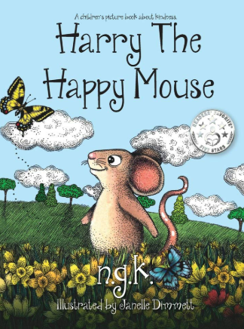  Harry the Happy Mouse by N.G.K | 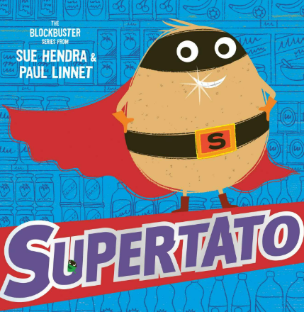  Supertato  By Sue Hendra and Paul Linnet |  | 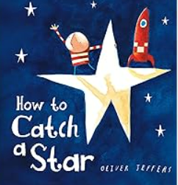  How to Catch a Star  By Oliver Jeffers | 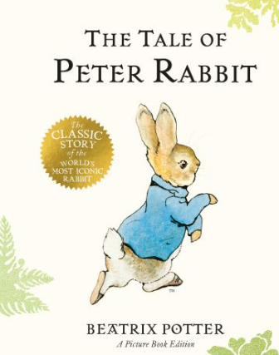  The Tale of Peter Rabbit  By Beatrix Potter | 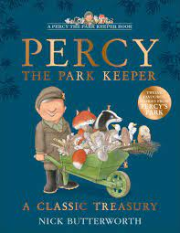  Percy the Park Kepper by Nick Butterworth | 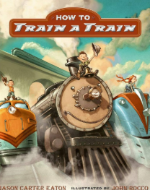  How to Train a Train  By Jason Carter Eaton
 | Year 1 children read many books as part of the Read, Write Inc phonics scheme as well as books chosen by the class teacher as daily “read aloud” books.
Year 2  (Inspiring texts used in English lessons) | 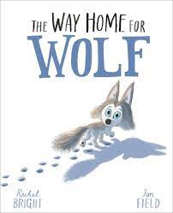  The Way Home for Wolf by Rachel Bright | 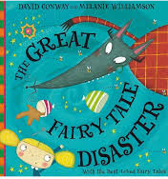  The Great Fairy Tale Disaster  By David Conway |  | 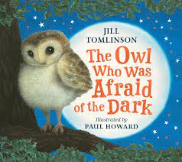  The Owl who was afraid of the Dark by Jill Tomlinson | 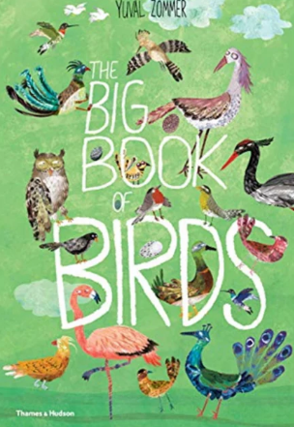 | 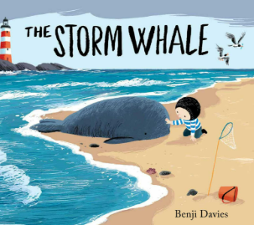  The Storm Whale  By Benji Davies | 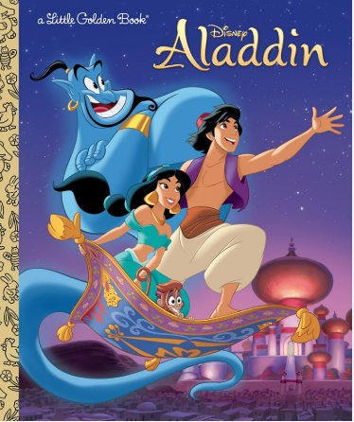  Aladdin  Disney Classic
Year 2 | Guided Reading in the Autumn Term taught within phonics groups following Read Write Inc. See Phonics policy for more information. |  | 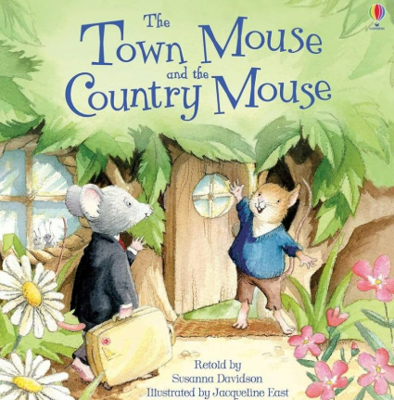  Town Mouse, Country Mouse by Libby Walden & Richard Jones (fables) |  | 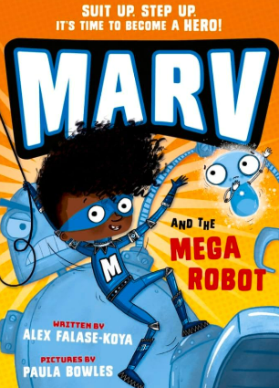  Marv and the Mega-Robot by Alex Falase-Koya (action) | 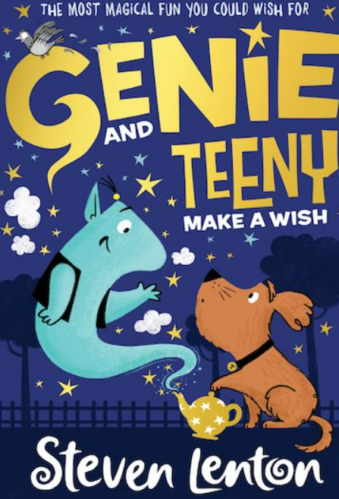  Genie and Teeny Make a Wish by Steven Lenten (fantasy) | 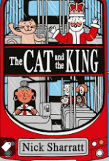  The Cat and he King by Nick Sharratt
 | We also have many “Read aloud” books chosen each year by the class teacher to reflect the interests and nature of the cohort of children. These are read daily (wherever possible).
Year 3 | 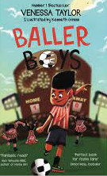  Baller Boys  by Vanessa Taylor | 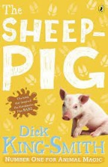  The Sheep-Pig  by Dick King Smith |  | 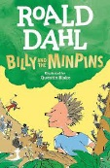  Billy and the Minpins  By Roald Dahl | 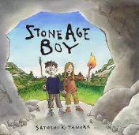  Stone Age Boy  by Satoshi Kimatura | 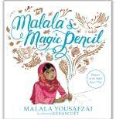  Malala’s Magic Pencil by Malala Yousafzai  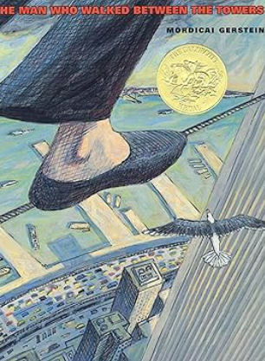  The Man who walked between the Towers by Mordicai Gernstein | 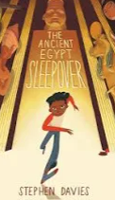  The Ancient Egyptian Sleepover  By Stephen Davies
Year 3  (Inspiring texts used in English lessons) | 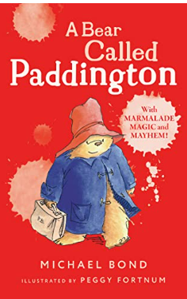  A Bear called Padington by Michael Bond | 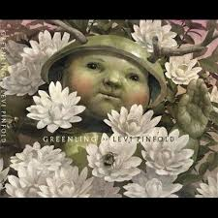  The Greenling  By Levi Pinfold |  | 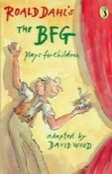  Playscripts based on Roald Dahl stories | 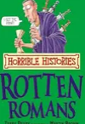  Horrible Histories Rotten Romans  By Terry Deary | 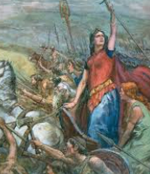  Queen Boudicca’s Revenge  By Steven Kenyon | 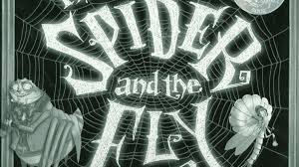  The Spider and the Fly  By Mary Howitt
 | We also have many “Read aloud” books chosen each year by the class teacher to reflect the interests and nature of the cohort of children. These are read daily (wherever possible).
Year 4 | 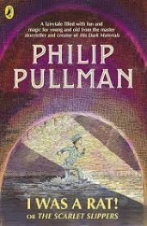  I Was A Rat  by Phillip Pulman | 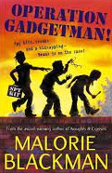  Operation Gadgetman by Malorie Blackman |  | 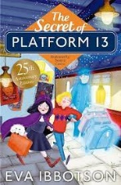  The Secret of Platform 13 by Eva Ibbotson | 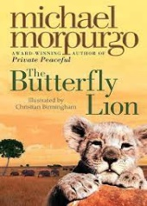  The Butterfly Lion  by Michael Morpurgo | 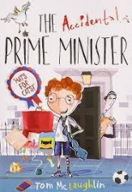  The Accidental Prime Minister by  Tom McLaughin | 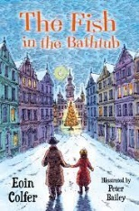  The Fish in the Bathtub  by Eoin Colfer
Year 4  (Inspiring texts used in English lessons) | 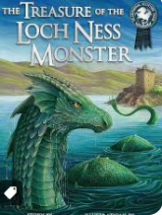  The Treasure of the Loch Ness Monster  By Lari Don | 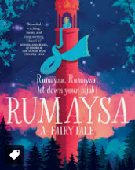  Rumaysa  By Radiya Hafiza |  | 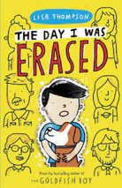  The Day I was Erased by Lisa Thompson | 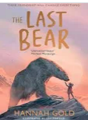  The Last Bear  By Hannah Gold | 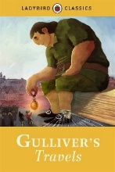  Gullivers Travels  Adapted | 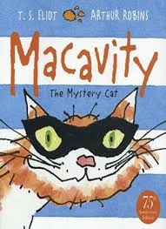  Macavity  By T.S.Elliot
 | We also have many “Read aloud” books chosen each year by the class teacher to reflect the interests and nature of the cohort of children. These are read daily (wherever possible)
Year 5 | 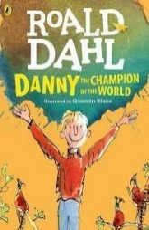  Danny the Champion of the World  by Roald Dahl | 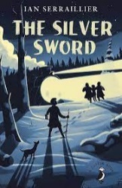  The Silver Sword  by Ian Serraillier |  | 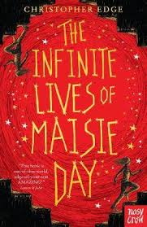  The Infinite Lives of Maisie Day  by Christopher Edge | 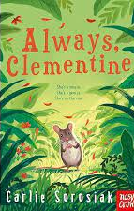  Always Clementine  by Carlie Sorosiak | 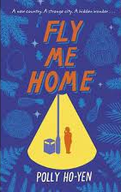  Fly Me Home  by Polly Ho-Yen | 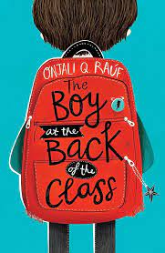  The Boy at The Back of The Class  by Onjali Rauf
(Inspiring texts used in English lessons) | 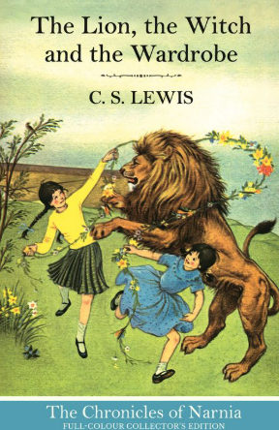  The Lion the Wicth and the Wardrobe by C.S. Lewis | 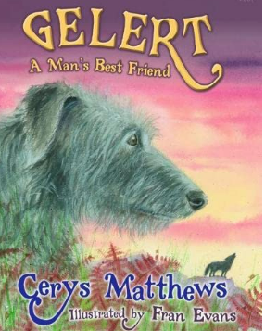  The Legend of Gelert |  | 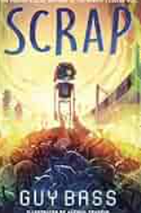  Scrap  By Guy Bass | 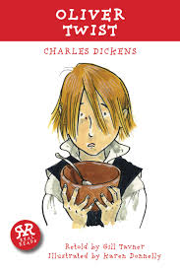  Oliver Twist  By Charles Dickens (retold by Gill Tavner) | 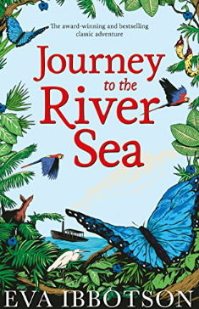  Journey to the River Sea by Eva Ibbotson | 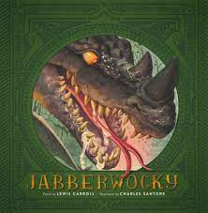  The Jabberwocky  By Lewis Carroll
 | We also have many “Read aloud” books chosen each year by the class teacher to reflect the interests and nature of the cohort of children. These are read daily (wherever possible)
Year 6 | 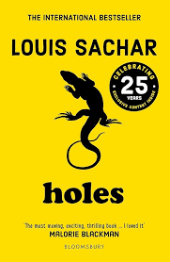  Holes  by Louis Sachar | 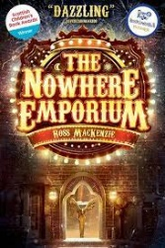  The Nowhere Emporium  by Ross Mackenzie |  | 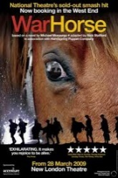  War Horse  by Michael Morpurgo | 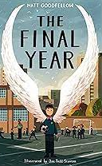  The Final Year  by Matt Goodfellow | 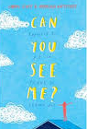  Can You See Me?  By Libby Scott | 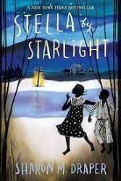  Stella by Starlight  by Sharon Draper
(Inspiring texts used in English lessons) | 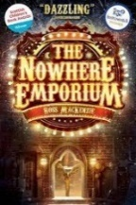  The Nowhere Emporium  by Ross Mackenzie | 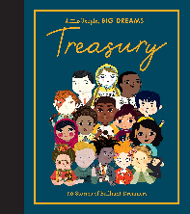  Little people big dreams  by Maria Isabel Sánchez Vegara |  | 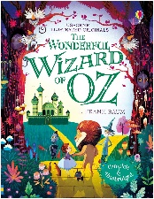  Wizard of Oz  by L. Frank Baum | 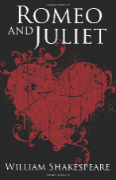  Romeo and Juliet  by William Shakespeare. | 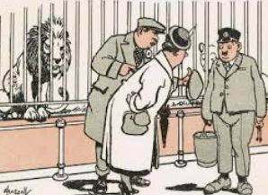  The Lion and Albert  By Marriott Edgar | 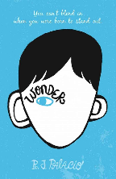  Wonder Book  by RJ Palacio
 | We also have many “Read aloud” books chosen each year by the class teacher to reflect the interests and nature of the cohort of children. These are read daily (wherever possible)

