English Curriculum Map
Year group | Autumn 1 | Autumn 2 | Spring 1 | Spring 2 | Summer 1 | Summer 2
Owlets  Focused texts (subject to change) | How do you feel?  Spot loves his friends  Bear and the picnic lunch  Are you ready?  We’re going on a pumpkin hunt. | That not my witch  Rosies walk  That’s not my hedgehog | Fidgety fish  Bright Stanley  What lives in the sea?  Winter | Noisy farm  On the farm  Muddle farm  Spot goes to the farm | Zoom, rocket zoom  Maisy goes on a plane  Tatty tractor | Dear zoo  Walking through the jungle  The tiger that came for tea  Aaaargh spider  Its quaking time
Nursery  Focused texts (subject to change) | The Selfish Crocodile.  Family and Me  Not fair, won’t share  All kinds of families  Meesha makes friends  Sharing a shell | Marney’s Mix-Up  We’re Going on a Leaf  Hunt  Fletcher and the Falling Leaves  The Gruffalos child  Jolly Christmas Postman  The elf chase. | Super Sid the Sausage Dog/Fire (Firefighters) Open wide (dentist)  Topsy and Tim meet the police (police)  You can’t call an elephant in an emergency (Fire fighters) | Hello Spring!  Tap the Magic Tree Fletcher and the Springtime Blossom  Three little pigs  Goldilocks and three bears  The gingerbread man | Super worm  What the Ladybird  Heard  The Very Hungry Caterpillar  Mad about minibeasts The Sleepy Bumblebee | Commotion in the  ocean  The Storm Whale  What the ladybird  heard at the seaside.  The Snail and The  Whale  Going on a treasure  hunt  Stella and the seagull
Reception | Narrative | Narrative | Narrative | Narrative | Narrative | Narrative
Reception | 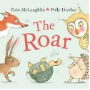 | 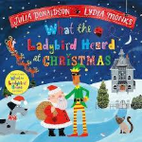 | 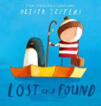 | 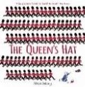 | 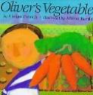 | 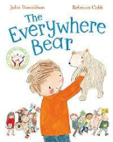
Reception | Non fiction | Non fiction | Non fiction | Non fiction | Non fiction | Non fiction
Reception | 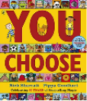 | 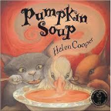 | Arctic Animals | Castles | 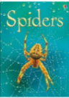 | Recount  Based on recent experience
Reception | Poetry | Poetry | Poetry | Poetry | Poetry | Poetry
Reception | 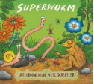 | “I am the Baker Man” | “Row, row, row your boat” | “London Bridge is falling down.” | “Tiny Caterpillar on a Leaf” | “Teddy Bears Picnic”
Year 1 | Stories with familiar settings | Story as a theme | Story as a theme | Classic stories | Stories with familiar settings | Stories with familiar settings
Year 1 | 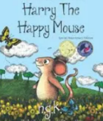 | 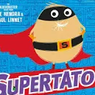 | 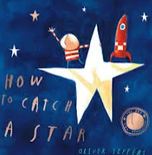 | 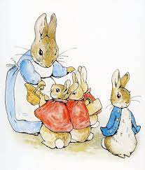 | 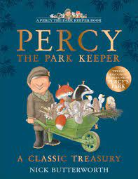 | 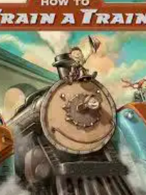
Year 1 | Information Texts | Instructions | Non-chronological reports | Information texts | Non-fiction booklets | Instructions  Persuasion
Year 1 | Poetry, songs and rhymes | Poems on theme | Poems on a theme | Traditional rhymes | Traditional rhymes | Traditional songs and rhymes
Year 2 | Narrative Bridging Unit | Fairy Tales with a Twist | Narrative: The Owl Who Was Afraid of the Dark |  | Narrative: The Storm Whale | Novel as a theme: Aladdin
Year 2 | 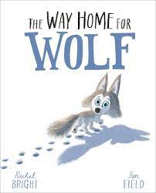 | 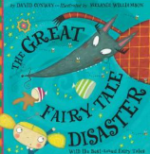 | 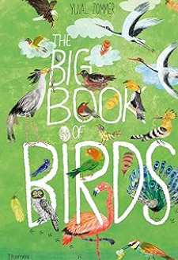  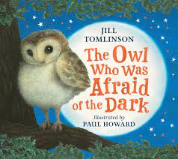 |  | 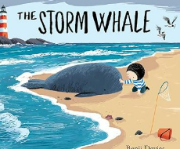 | 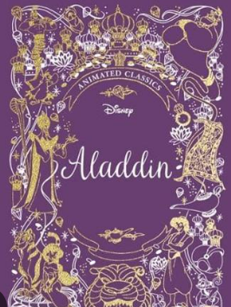
Year 2 | Information poster | Instructions | Non chronolgical report  Persuasion |  | Recount  Letters | Persuasion  Letters
Year 2 |  |  | Poetry – Riddles |  | Poetry – classic poetry | Poems with a structure
Year 3 | A bear called Paddington | Folk tales | Narrative/Playscripts | Historical non-fiction | Historical fiction | Narrative poetry
Year 3 | 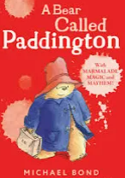 | 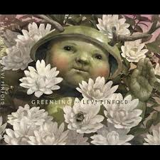 | 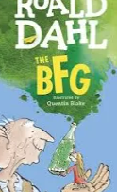 | 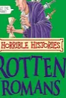 | 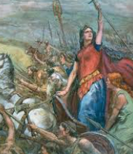 | 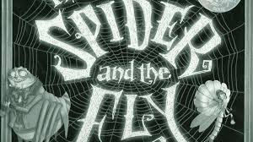
Year 3 | Information guide | Letters and Instructions | Non chron – linked to Volcanoes | Information texts: trifold leaflets |  | Recount  Persuasion
Year 3 |  |  | Humorous poetry |  |  | Narrative poetry
Year 4 | Bridging Unit- The Loch Ness Monster | Fairy Tales | Stories with issues and dilemmas | Narrative Story Openings | Narrative | Classic Poetry
Year 4 | 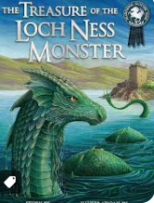 | 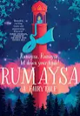 | 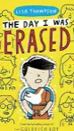 | 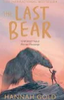 | 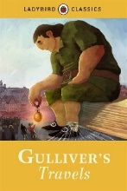 | 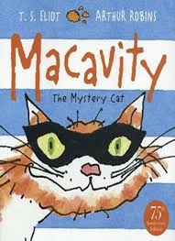
Year 4 | Information texts  Infographs | Discussion & debate | Persuasive adverts | Explanation Text | Information poster  Persuasion | Recounts  News broadcasts
Year 4 | Poetry Performance | Poetry with a structure |  | Persuasive Poetry |  | Classic Poetry  Poetry Performance
Year 5 | Narrative: Classic Fiction | Narrative: legends | Narrative: Science Fiction | Narrative: Historical Setting | Narrative | Poetry
 | 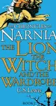 | 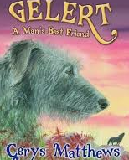 | 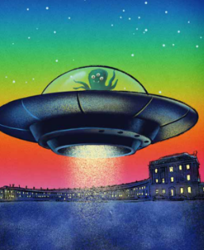 | 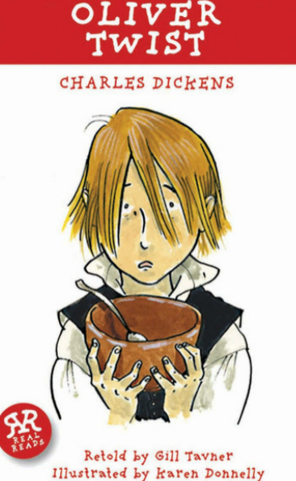 | 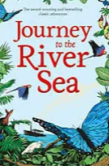 | 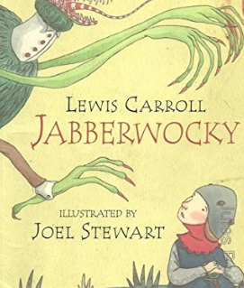
 | Non-chronological report | Persuasion |  |  | Debates | Informal letters
 |  |  | Poems with figurative language | Classic narrative poetry |  | Classic poetry
Year 6 | Novel as a theme | Biographies | Classic fiction | Shakespeare | Narrative poem | Modern fiction
Year 6 | 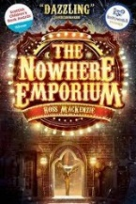 | 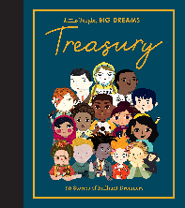 | 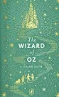 | 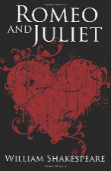 | 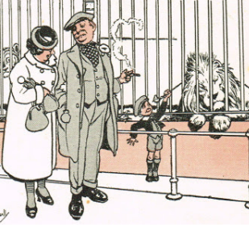 | 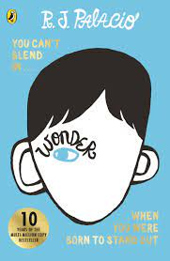
 | Reports, discussions, debates |  |  | Recount, newspaper articles, discussion and debate | Persuasion – formal letters/emails, adverts and reviews | Biography
 |  | Poetry – songs and lyrics |  |  |  | Songs and lyrics

